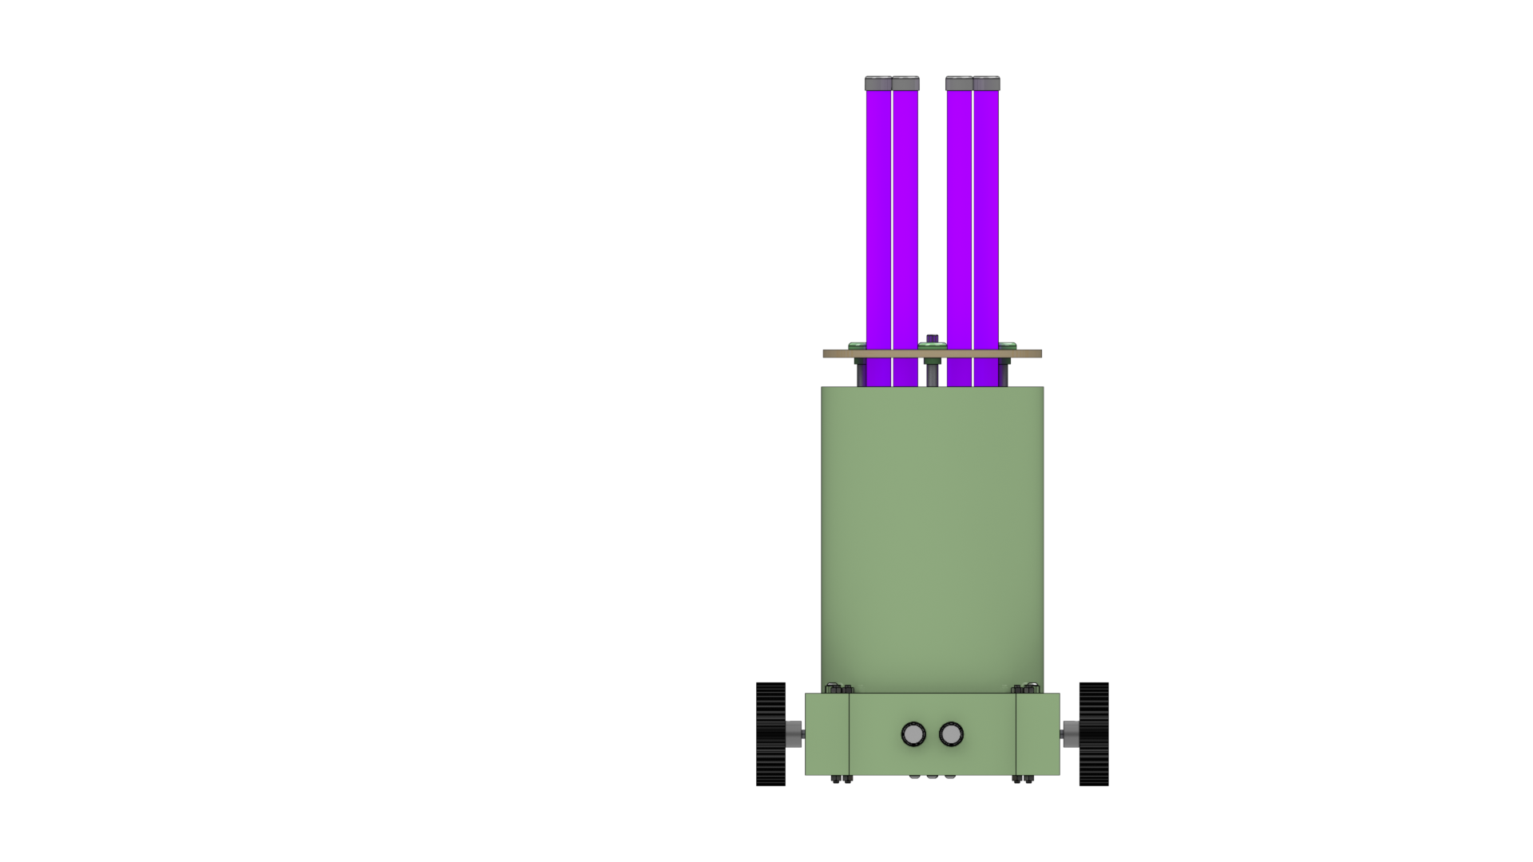

|  |  |
| --- | --- |
| INDUSTRIALINTERNSHIPREPORT | |
|  |  |
| JEMMA CLEANNING BOTJULY 2020PARTH PATEL (17BEE109) |  |

**CONTENTS**

1. Basic Details
2. Acknowledgement
3. Certification
4. Problem Statement
5. Mechanical Specification of Robot
6. Electrical Specification of Robot

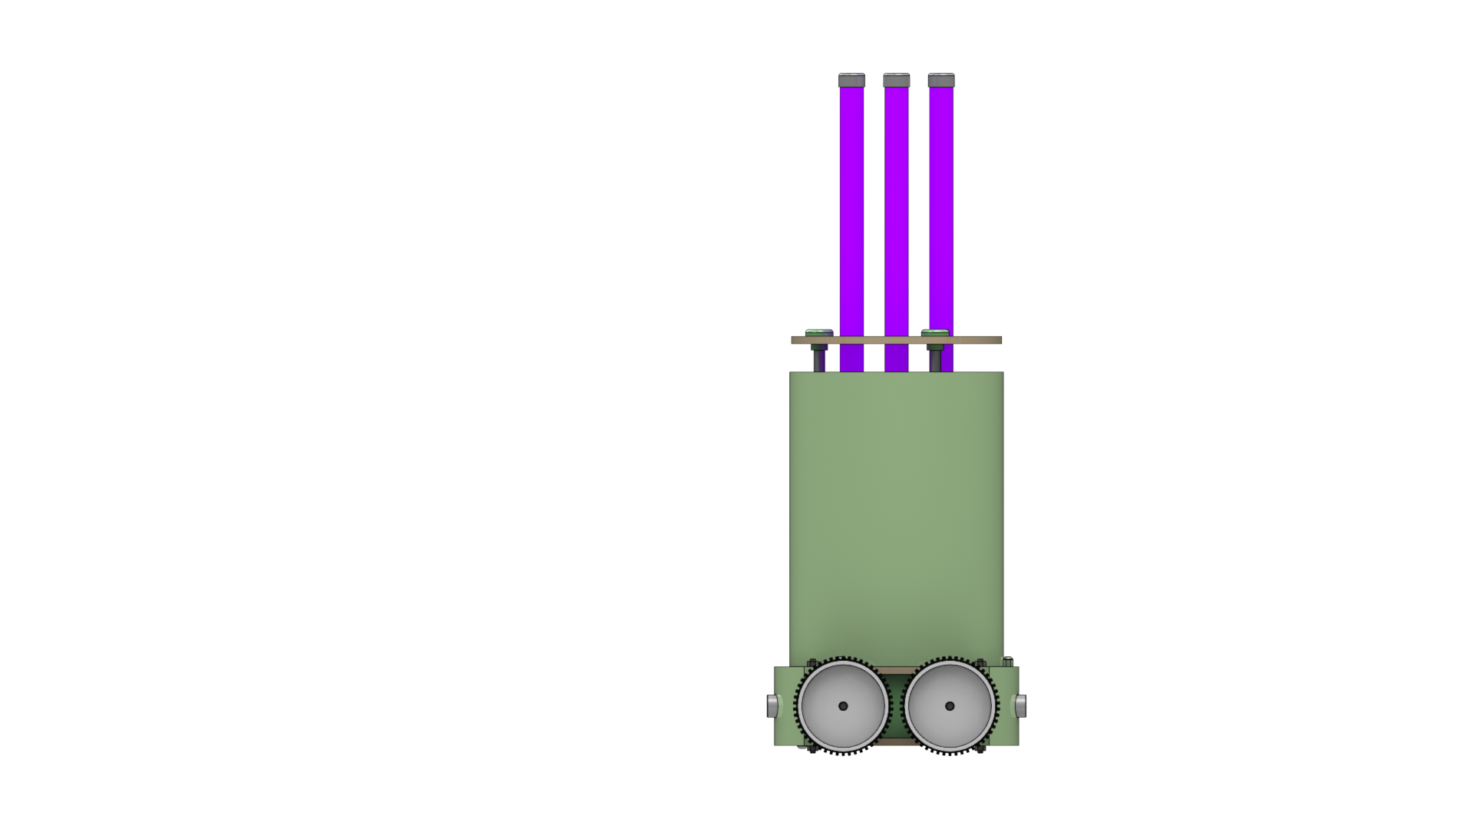

|  |  |
| --- | --- |
| ABOUT JEMMA | |
| BASIC DETAILS The robot for motion is equipped with four 12V dc motors for independent four-wheel drive with each motor equipped with a separate driver circuit to have complete 2 degree of motion which motion incorporated with lateral motion, circular motion and on-position rotation included.  The robot is equipped with two ultrasonic sensors for avoiding collisions.  There exists six UV-C Lamps on the robot with 34V operating voltage each.  The robot operates in three modes:   1. Autonomous Mode 2. Remote controlled Mode 3. Pre-planned Route Mode | **Clean efficiently, Clean safely** |
|  |

**ACKNOWNLEDGMENT**

I would like to express my deepest appreciation to all those who provided me the possibility to complete this report.  A special gratitude I give to our mentor, Mr. Vipin Shukla, whose contribution in stimulating suggestions and encouragement, helped me to coordinate my project especially in designing this project.

A special thanks goes to my team mate, Parin Patel, who helped me to assemble the parts and gave suggestion about the project Jemma Cleaning Bot. I have to appreciate the guidance given by other supervisor as well as the panels especially in our project presentation that has improved our presentation skills thanks to their comment and advices.



**CERTIFICATION**

This is to certify that the project report entitled **Jemma Cleaning Bot**, submitted to the Department of Electrical Engineering, Pandit Deendayal Petroleum University, under the event for Industrial Internship for Innovation and Incubation Cell, PDPU details accomplishment of the Problem statement **COVID 8 “UV Sanitization using Robot”**.

The report certifies that **Mr. Parth Patel (17BEE109)** has successfully completed the project and has along with it submitted the report under the supervision of **Mr. Vipin Shukla** on his successful build and design within.

**Dr. Praghnesh Bhatt**

Associate Professor

Dept. of Electrical Engineering

Head of the Department

**Mr. Vipin Shukla**

Assistant Professor

Dept. of Electrical Engineering

Project Mentor

##### PROBLEM STATEMENT

##### There exist four major problems when it comes to current cleaning methods:

* **TIME** is essential when it comes to cleaning homes. It needs to be done as soon as a person visits home. Manual cleaning takes a lot of time which can increase the risk of exposure to virus to residents.
* **AVAILIBILITY** of proper cleaning appliances and chemicals are not accessible to many people.
* The current cleaning solution using Alcohol based disinfectants causes **DAMAGE** to the cleaning surface and the human skin as alcohol is a strong dehydrator.
* Proper cleaning **PROCEDURE** is not known to many people in country.

**MECHANICAL SPECIFICATION OF ROBOT**

The robot is designed to be scalable with minimal resources available. The mechanical design can be made using just two processes:

1. FDM Manufacturing
2. Laser Cutting

The 3D printed parts are built using PETG Material which enables it to be manufactured on any 3D printer because it being easy to print at high speeds.

The Bottom and Top can be Laser Cut on 5.5mm MDF Board using a cheap 50W CO2 Laser Cutter at a high speed of 75 mm/s.

Motion design:

1. 8mm Stainless Steel Rod
2. LM8UU Linear Bearing
3. 8mm Threaded Rod for Lead Screw

##### ELECTRICAL SPECIFICATION OF ROBOT

1. Robot Specification
2. Alarm Circuit
3. 555 Datasheet
4. 556 Datasheet
5. Motor Datasheet
6. Motor Driver Circuit
7. MOSFET Datasheet
8. UV-C Tube Datasheet

##### ROBOT SPECIFICATION

* Robot Specification:
  + Maximum Weight: 15.5kg
  + Maximum Speed: 0.8 m/s
* Motors:
  + Name: HC315MG-004 dc motor
  + Operating Voltage: 12V
  + Maximum Current: 7.5A
  + Maximum Torque: 100m N-m
  + Maximum Power: 40W
  + Maximum Speed: 18,000 rpm
  + Required Speed: 1.8A
  + Required Efficiency: 68%
  + Required Speed: 12,800 rpm
  + Required Torque: 22.468m N-m
  + No. of Units: 4
* UV-C Lamp Specification:
  + Rated Voltage: 34V
  + Rated Current: 0.6A
  + Rated Output Power: 11W
  + No. of Units: 6
* MOSFET Specifications
  + Name: STP55NF06L
  + VDS max: 60V
  + IDS max: 55A
  + RDS ON:18mΩ
  + VGS:16V

1. **ALARM CIRCUIT**

To reduce the load off the **ATMEGA 328P** microcontroller modular circuit design was kept in focus. Due to this, the alarm system is controlled by two 555 Timers integrated in a single **NE556 IC** working with:

1. Timer 1: Monostable mode
2. 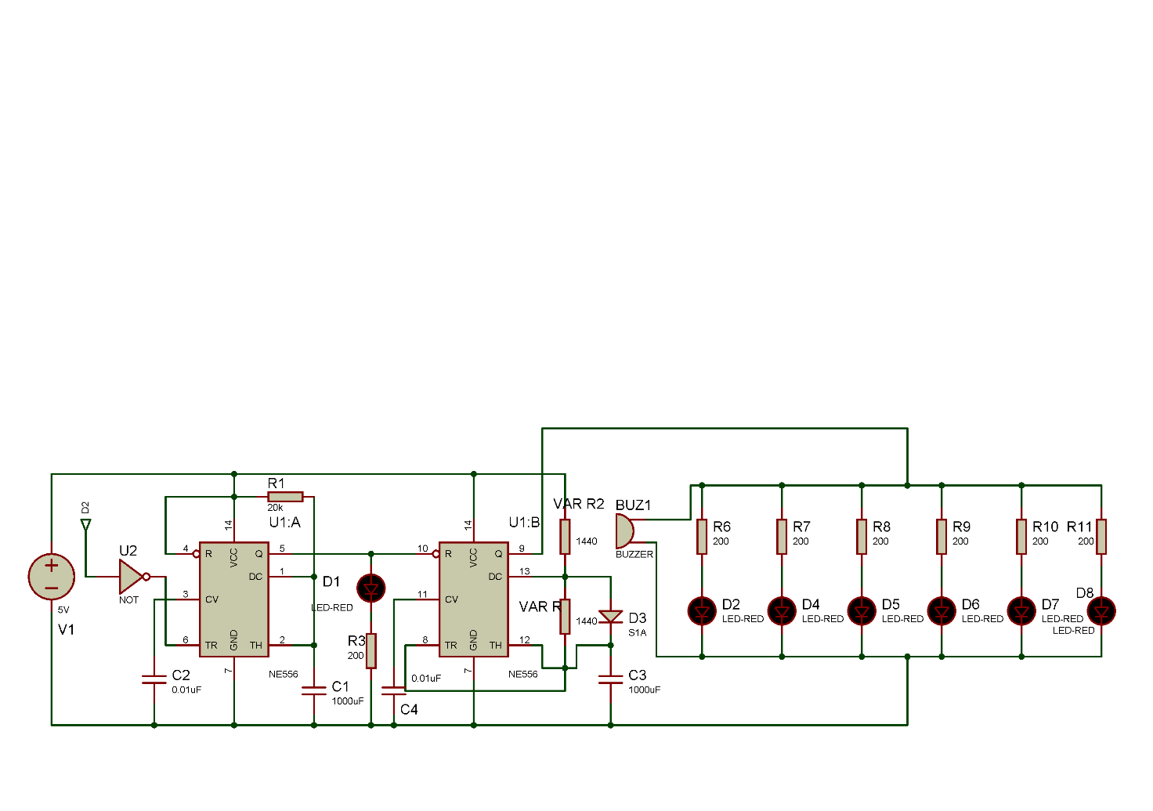Timer 2: Multi stable Mode

555 triggers at the ACTIVE LOW edge signal, due to this, a **NOT GATE** is attached in front of the **TRIGGER PIN** of the Timer 1. This enables to Atmega 328P to remain in **LOW STATE** when not in need. When the UV sanitization process is about to start, the **D2** digital pin triggers to **ACTIVE HIGH** which results output of NOT gate to ACTIVE LOW which enable the Timer 1 to function.

Timer 1 works in Monostable mode with a duration of **20s** which turns **ON** the Timer 2 by supplying the **5V** to the **RESET** pin of Timer 2 which enables it to operate at a frequency of **1Hz**.

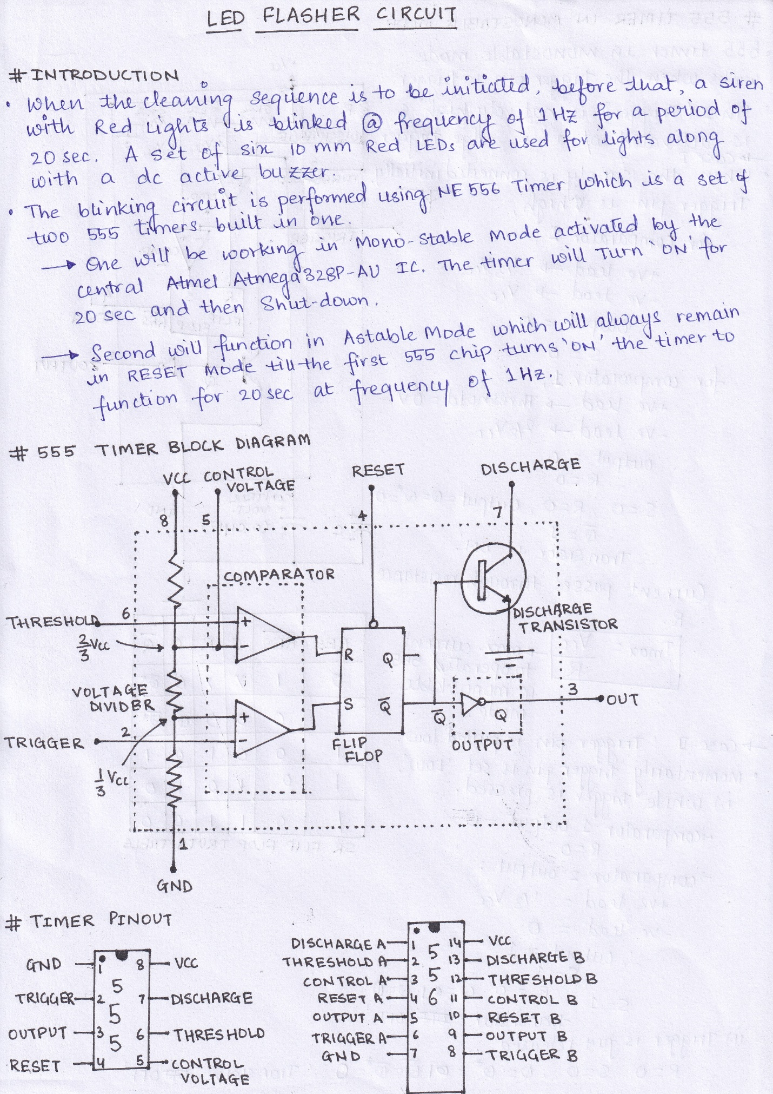

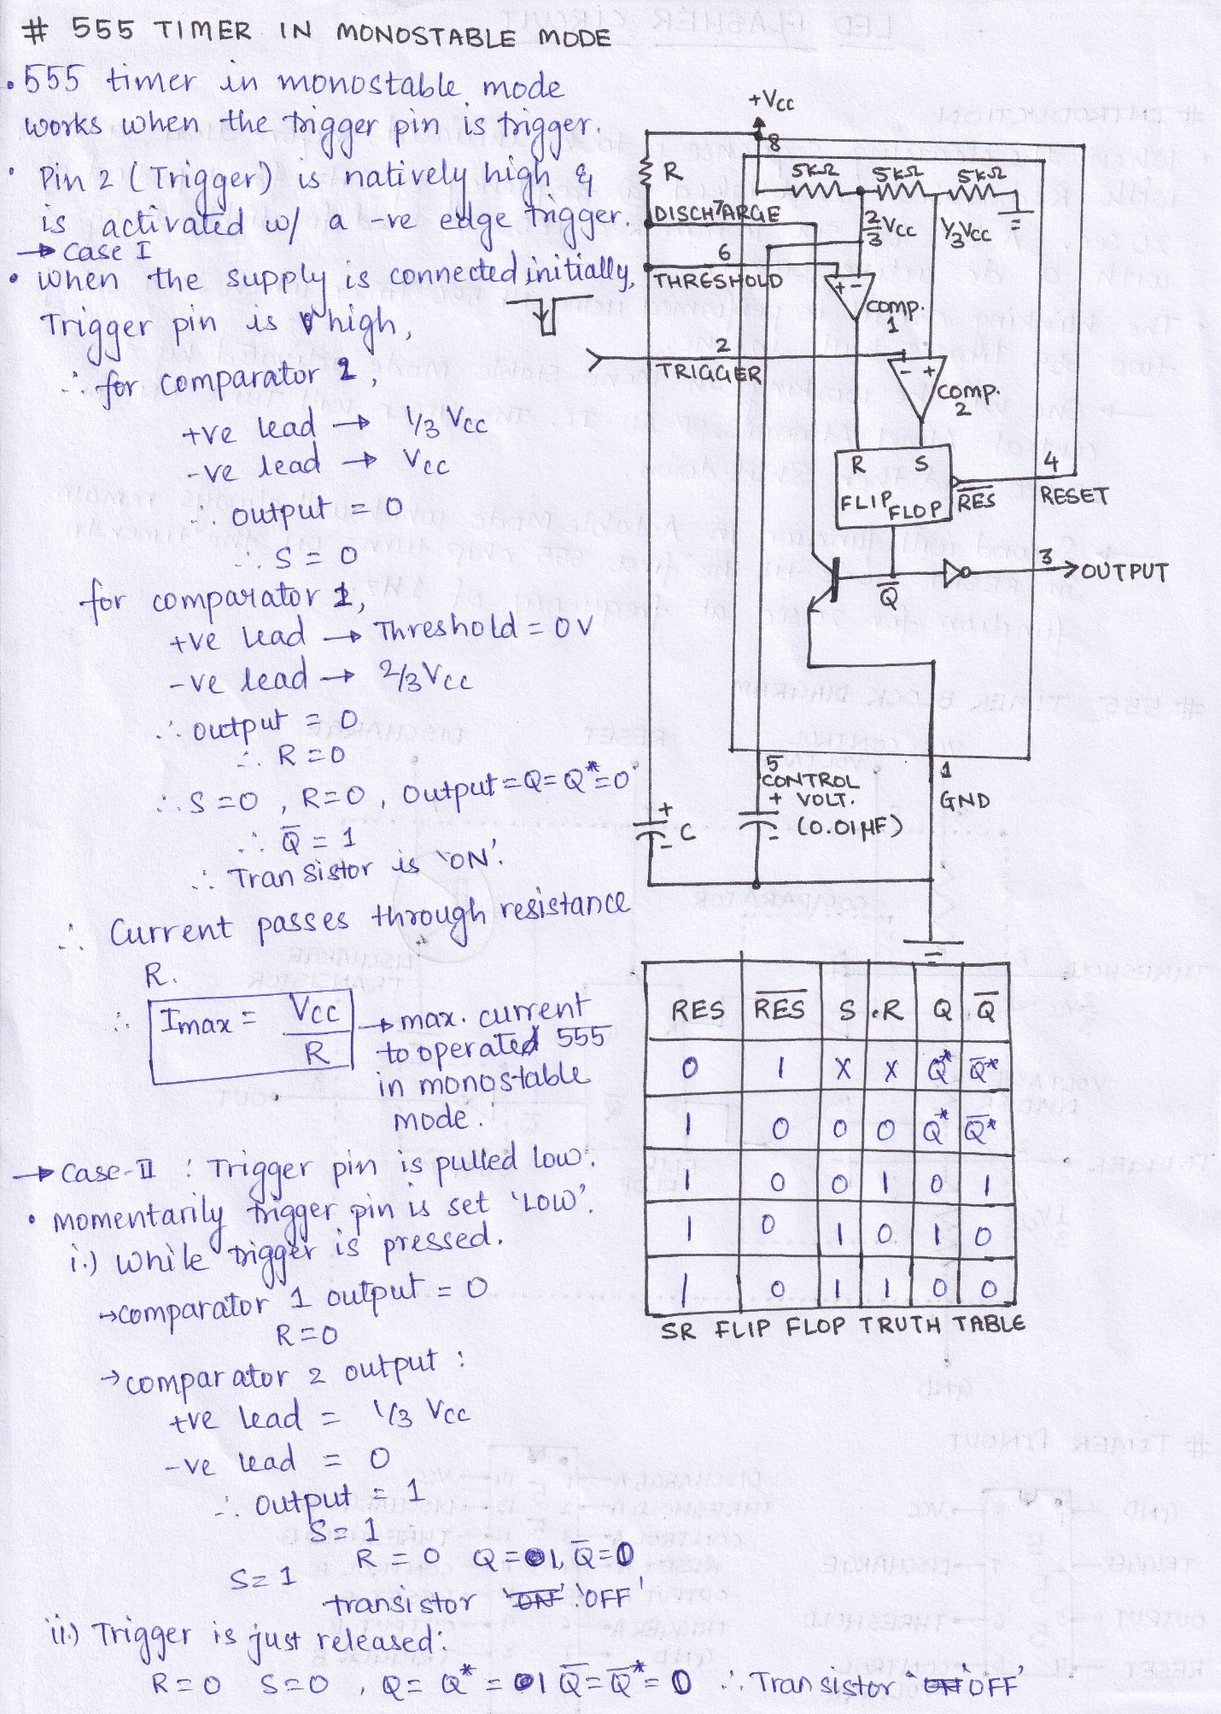

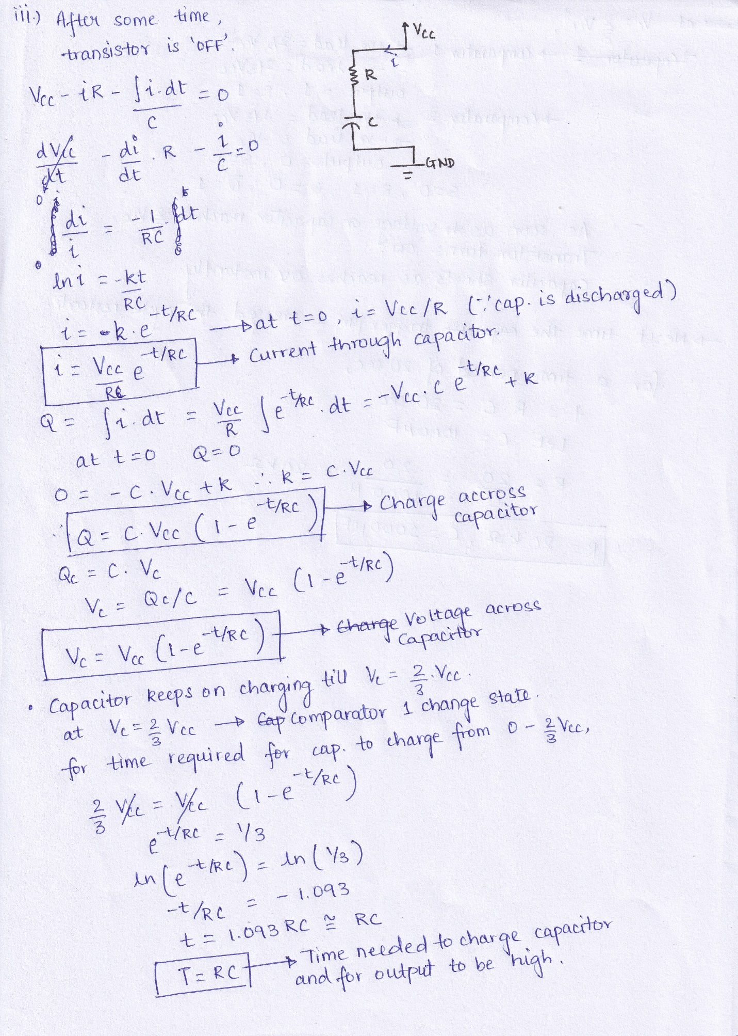

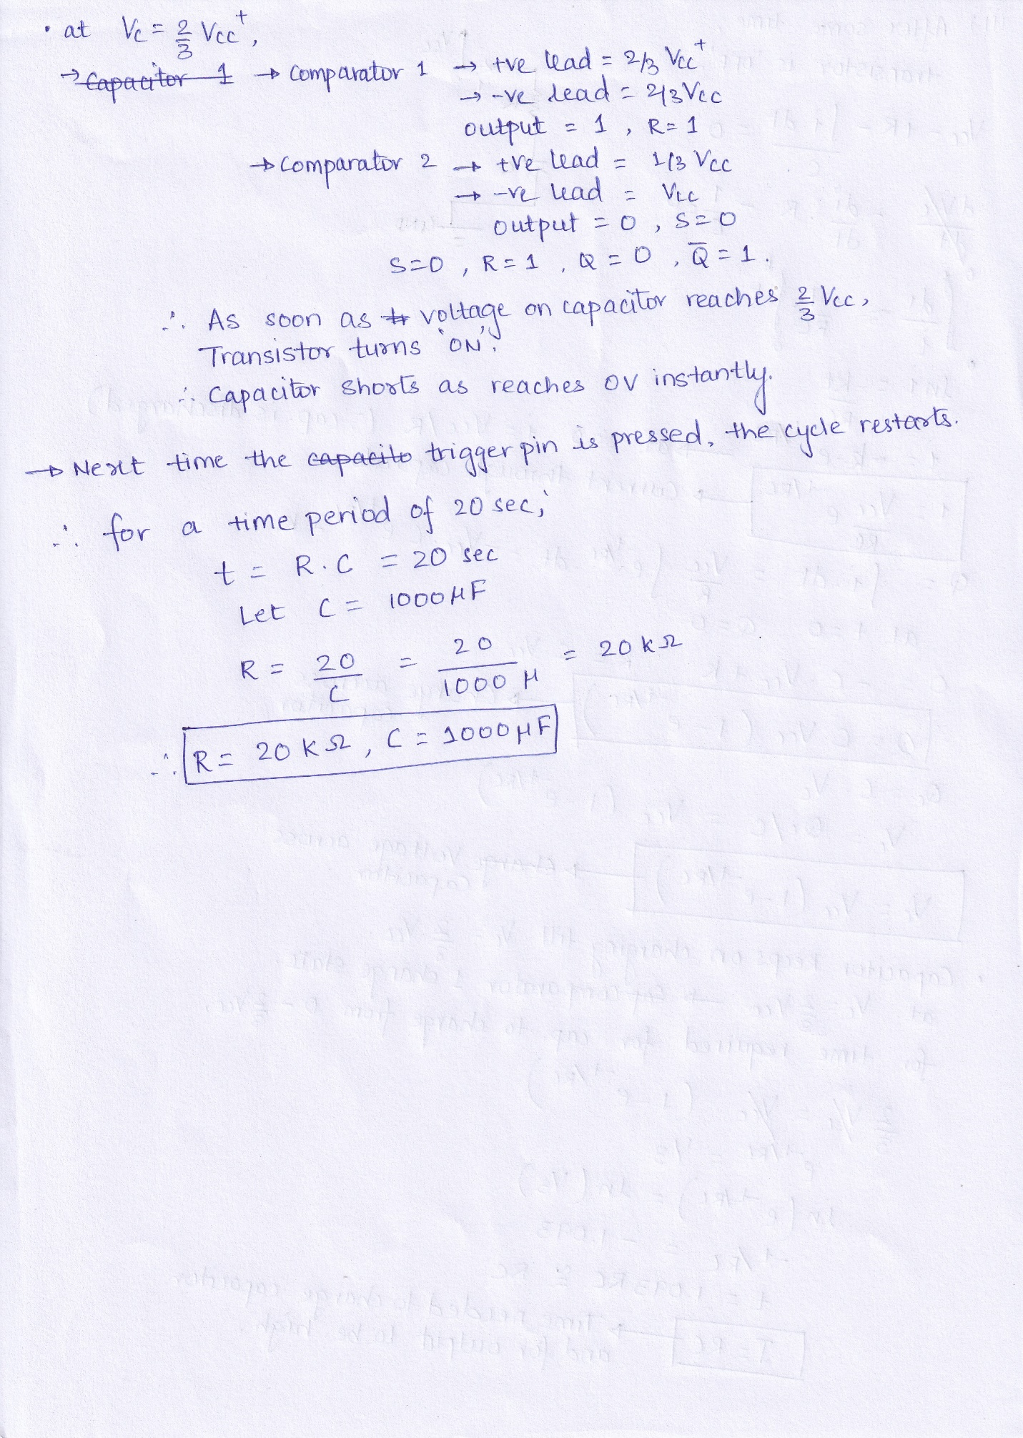

1. **555 Datasheet**

555 Internal Schematic Diagram

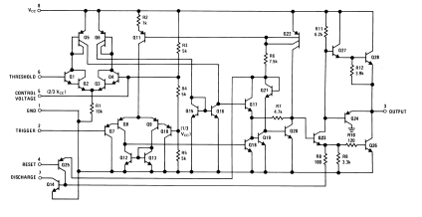555 Electrical Characteristics

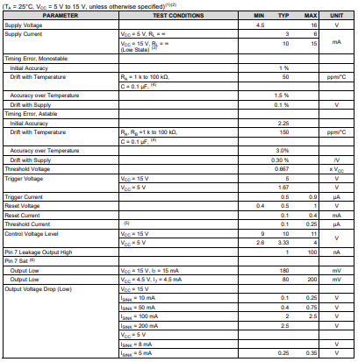

1. **556 Datasheet**

556 Pinout

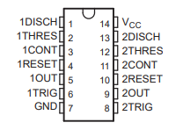

556 Electrical Characteristics

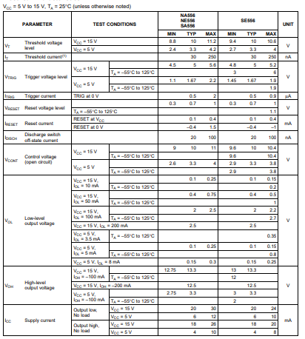

556 Ratings

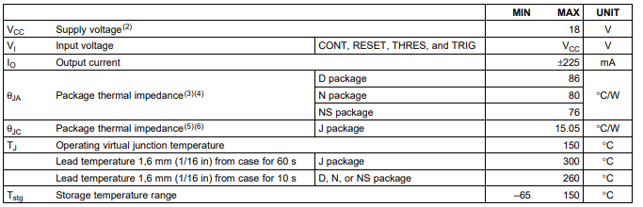

1. **Motor Datasheet**

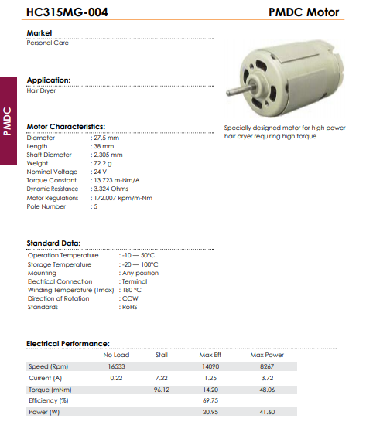

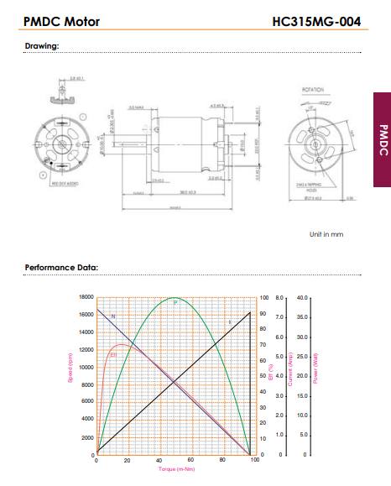

1. **Motor Driver Circuit**

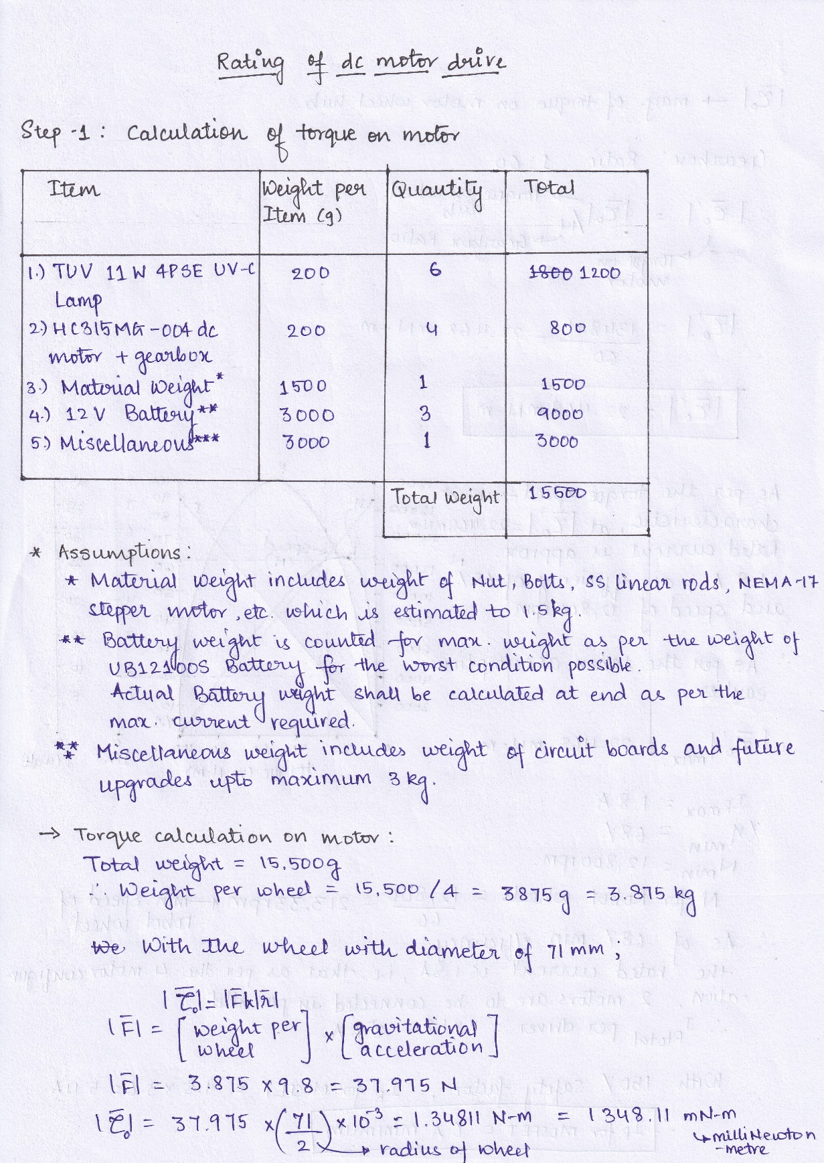

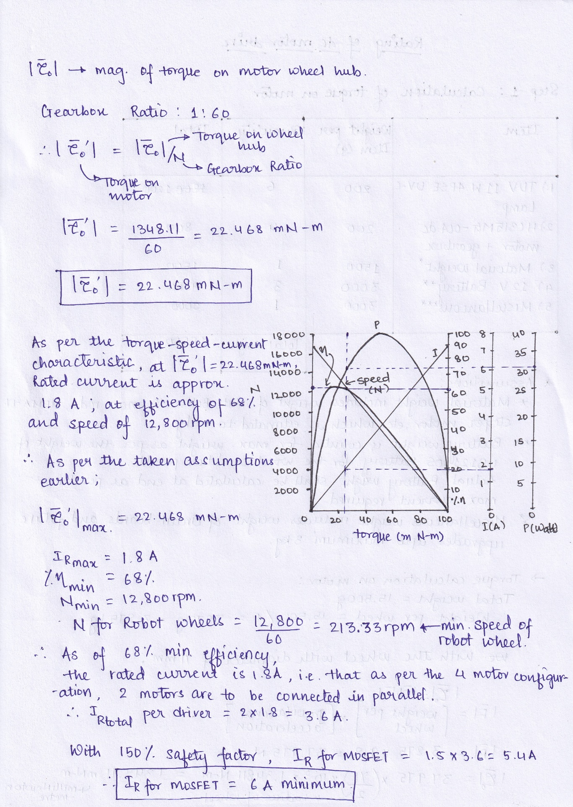

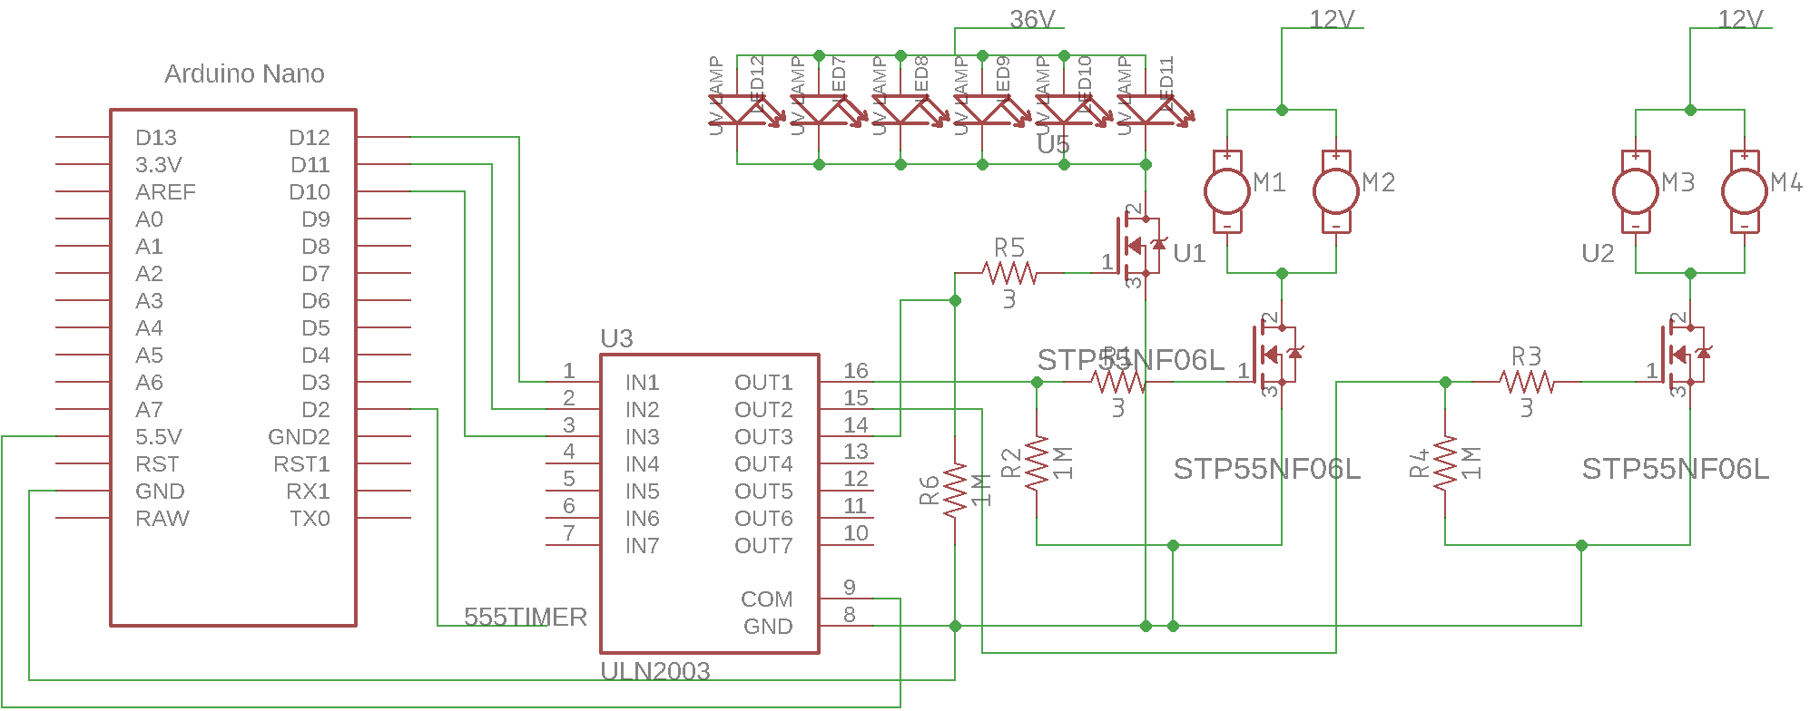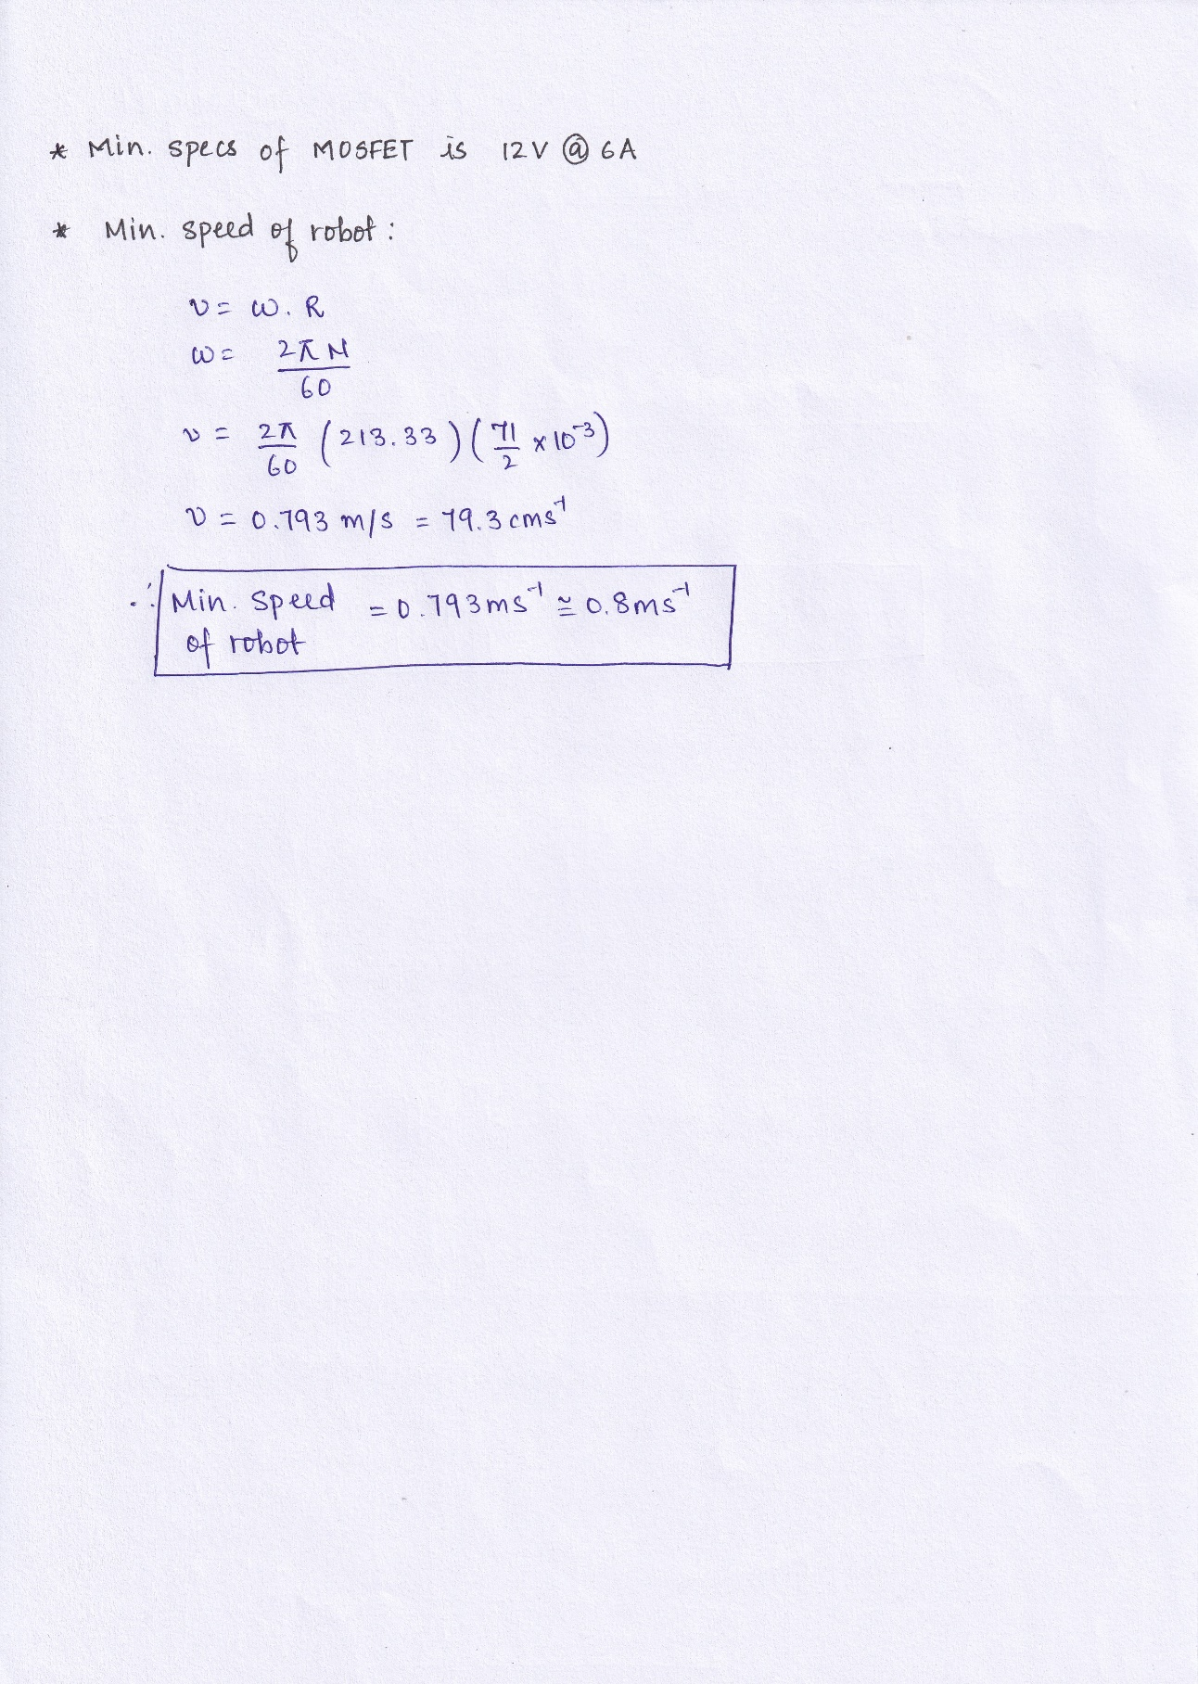

1. **MOSFET Datasheet STB55NF06L**

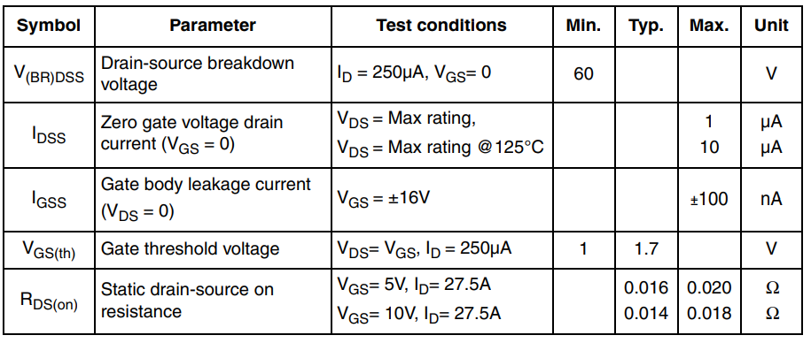ON/OFF STATES CHARACTERISTICS

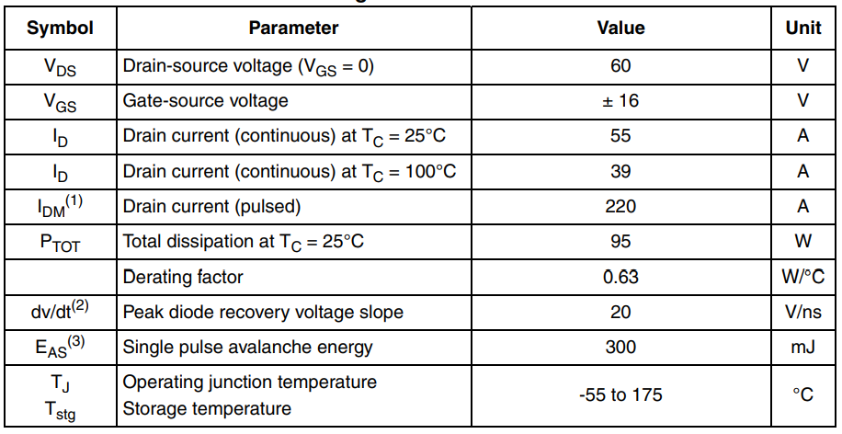ELECTRICAL CHARACTERISTICS

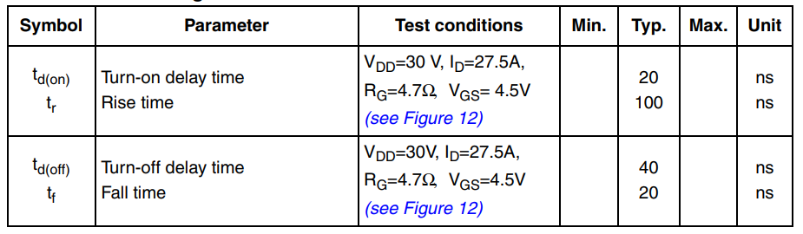SWITCHING TIMES

SOURCE DRAIN DIODE

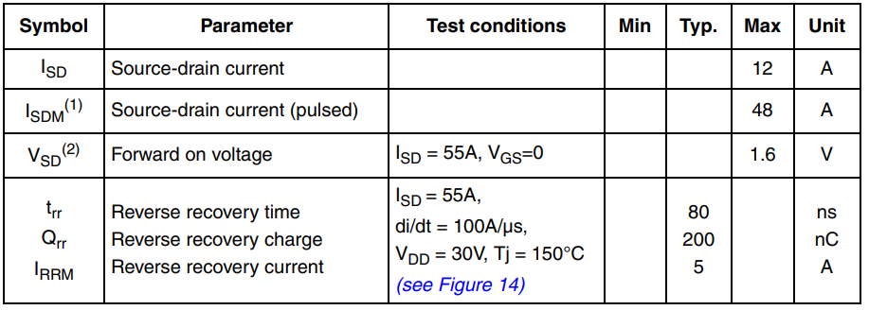

1. **UV-C Tube Datasheet**

